**Krishnakumar.P** 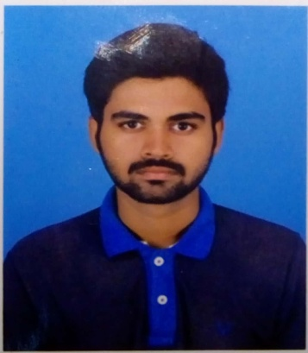

[432000krish@gmail.com](mailto:432000krish@gmail.com)

+916383875919

**OBJECTIVE**

To work in a highly competitive environment with a perfect

challenge by contributing the best for the growth of the organization

while ensuring growth in personal career.

**EDUCATION**

* **Bachelor of Engineering (B.E), Mechatronics (2017 - 2021)**

Sri Krishna College of Engineering and Technology,Coimbatore.

CGPA :8.4/10(Upto 6th Semester)

* **XII (Senior Secondary), Science**

Sri sowdambika convent Matriculation Higher Secondary School,Aruppukottai.

Percentage :93.58%

* **X (Secondary)**

Devangar Higher secondary school, Aruppukottai.

Percentage:92.2%

**AREA OF INTEREST**

Strength of Materials, Hydraulics and Pnuematics.

Product Design and Manufacturing.

**IMPLANT TRAINING**

* **Tractor Manufacturing**

Tafe Pvt Ltd

18 Nov2019 -22 Nov 2019

Tractors and farm equipments is a special purpose tractor manfacturers located in Madurai.

My internship was focused to gain knowledge on a Manfacturing

Tractors also working in the Tractors assembly,Load testing and tractors assembly section.

* **Foils Manufacturing**

Hicon Foils Pvt Ltd

25 Dec 2019-30 Dec 2019

To Learn about the Manufacturing of the Aluminium Foils Seals,Paper Foils Seals

Induction Wad and Safety Seal wad and all kind of Plastic Containers etc.This Industry

Is located in Aruppukottai.

**HOBBIES**

* **Playing cricket and Foot Ball.**
* **Reading News Paper and Books.**

**CERTIFICATION**

* **Coursera** Certification for”Introduction to Self driving cars”.
* **Coursera** Certification for “state estimation and localization of self driving cars”.
* **Coursera** Certification for “Fundamentals Macroscopic and Microscopic Thermodynamics.
* **NPTEL Online Certification** in the course named “Speaking Effectively”.
* **NASSCOM ONLINE CERTIFICATION** in the course named ”Foundation of Artificial Intelligence Program.

**COMPETITION**

* **Participated in YUKTA** in Mr. Mechanic competitions manufacturing of Machines and Manufacturing components competitions.

**PROJECTS**

* **Automatic Solar Tracker and Energy Generation System**

The objective of the project is to develop a Electric power generation and

tracking the solar power. The system was manufactured by using solar panels and arduino for controlling and tracking system(solar tracker) by solar and energy meters to read the output from the solar panels.

* **Design and Fabrication of Automatic Rain Water Sensing and Closing Window System**

This project discusses about using Rain water sensing Window in the field

of protect the interior of the house as it automatically by sensing the water. The concept of sensing rain water to close the window is not new it has been developed to use in the automobile sector .

**SKILLS**

**Software:** Solid Works ,AutoCad ,Arduino, Ansys, Master Cam.

**Programming Languages:** C and C++ language

**Languages :**Tamil(R/W/S),kanadam(Speak only),English(R/W/S).

**PERSONEL DETAILS**

**Date of Birth :**04/03/2000

**Father’s Name :**Pandiarajan.S

**Mother’s Name :**Vijayalakshmi.P

**Address :**10/1,MDR Nagar East, Chokalingapuram, Aruppukottai

Virudhunagar-626101.

**DECLARATION**

The information furnished above is correct to the best of my knowledge.

**DATE SIGNATURE**